**Apéndice normativo 1. Lista de áreas infestadas o supuestamente infestadas por la Palomilla Gitana Norteamericana (*Lymantria dispar*) en Canadá y los Estados Unidos de América**

**Nota:** Estas áreas reguladas están sujetas a cambios derivados de la revisión de la información científica relevante con respecto a los resultados del monitoreo actualizado por las autoridades fitosanitarias de Canadá y los Estados Unidos de América.

Se podrá consultar esta información actualizada por los medios electrónicos o aquellos que la Secretaría ponga a disposición del público.

**Nota:** Información tomada de <https://www.inspection.gc.ca/plant-health/plant-pests-invasive-species/directives/forest-products/d-98-09/appendix-1/eng/1343832991660/1343834043533>

**Canada (Ontario, Quebec and Atlantic Regions)**

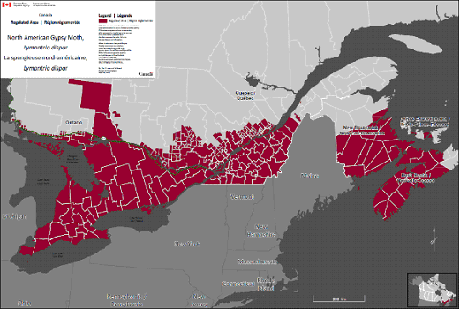

**Palomilla Gitana Norteamericana** (*Lymantria dispar*)– Mapa de áreas reguladas en Canadá.

**Región del Atlántico**

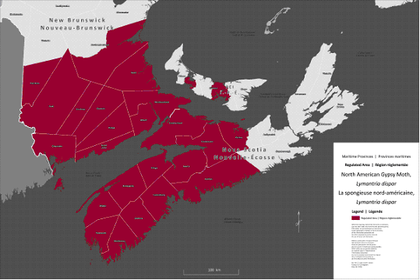

**Palomilla Gitana Norteamericana** (*Lymantria dispar*)– Mapa de áreas reguladas en el Atlántico.

|  |  |
| --- | --- |
| Nova Scotia – Lista de áreas infestadas por Palomilla Gitana Norteamericana (*Lymantria dispar*) | |
| **Condado** | **Área Regulada por infestaciones parciales en el Condado** |
| Annapolis |  |
| Colchester |  |
| Cumberland |  |
| Digby |  |
| Halifax |  |
| Hants |  |
| Kings |  |
| Lunenburg |  |
| § Pictou | All lands in Pictou County, NS west of and contained within the following boundary described as:  Start where SHORE RD crosses the bridge in MERIGOMISH,  Continue east on SHORE RD to FORBES MILL RD,  Continue south on FORBES MILL RD to SIMPSON NO 3 RD,  Continue South on SIMPSON NO 3 RD to PIEDMONT VALLEY RD,  Continue South on PIEDMONT VALLEY RD to HIGHWAY 4,  Continue Southwest on HIGHWAY 4 to FRENCH RIVER RD,  Continue South on FRENCH RIVER RD to J W MEIKLE RD,  Continue Southwest on J W MEIKLE RD to MEIKLEFIELD RD,  Continue West on MEIKLEFIELD RD to SHERBROOKE RD,  Continue South on SHERBROOKE RD to TOWER RD,  Continue South on TOWER RD to BLANCHARD RD,  Continue West on BLANCHARD RD to CUMMINGS MOUNTAIN RD,  Continue South on CUMMINGS MOUNTAIN RD to EAST RIVER EAST SIDE RD,  Continue West on EAST RIVER EAST SIDE RD to EAST RIVER WEST SIDE RD,  Continue South on EAST RIVER WEST SIDE RD to HIGHWAY 348,  Continue South on HIGHWAY 348 to the Pictou / Guysborough County Line,  Continue West following the Pictou / Guysborough County Line to the Pictou / Colchester County Line |
| Queens |  |
| Shelburne |  |
| Yarmouth |  |

|  |  |
| --- | --- |
| New Brunswick - Lista de áreas infestadas por Palomilla Gitana Norteamericana (*Lymantria dispar*) | |
| **Condado** | **Área Regulada por infestaciones parciales en el Condado** |
| Albert |  |
| Carleton |  |
| Charlotte |  |
| § Kent |  |
| Kings |  |
| **§ Northumberland** | All lands in Northumberland County, NB south of the following boundary described as:  Start where the Northumberland Strait meets the Northumberland / Gloucester County Line  Continue west on county line to road named Portage River,  Continue South on Portage River to Baisley Road,  Continue South on Baisley Road to Route 430,  Continue South on Route 430 to Route 425,  Continue South on Route 425 to Route 420,  Continue West on Route 420 to Route 108,  Continue West on Route 108 to the Northumberland / York County Line |
| Queens |  |
| Saint John |  |
| Sunbury |  |
| York |  |
| Westmorland |  |

|  |  |
| --- | --- |
| Prince Edward Island - Lista de áreas infestadas por Palomilla Gitana Norteamericana (*Lymantria dispar*) | |
| **Condados, Municipios Regionales y Distritos** | **Área Regulada por infestaciones parciales en el Condado** |
| **§ Prince** | Start where Route 12 crosses Grand River  Continue East to Allen Road (Route 122)  Continue South to Western Road (Route 2)  Continue West to St Nicholas Road  Continue South to Route 11  Continue South-East to Sunbury Cove Road  Continue South on Sunbury Cove Road to end of road, then due South to Water  Continue South then East to where water meets land near Campbells Shore Road (including all intercoastal islands)  Continue East on Campbells Shore Road to Chelton Road  Continue North-East to Fernwood Road (Route 119)  Continue East to Route 112  Continue North to Callbeck Street / Dunk River Road (Route 171)  Continue East to Mill Road (Route 110)  Continue North to Freetown Road (Route 8)  Continue East to Cairns Road (Route 110)  Continue North to Blue Shank Road (Route 107)  Continue East to MacIntyre Road (Route 110)  Continue North to Route 2  Continue West to Old Station Road (Route 110)  Continue North-West to Clermont Road (Route 106)  Continue North to bridge over Indian River  Then continue over water to starting point (including all intercoastal islands) |

|  |  |
| --- | --- |
| § Queens | Start where Route 6 crosses Wheatley River near Cymbria  Continue East then South on Route 6 to Crooked Creek Road (Route 251)  Continue South-West to New Glasgow Road (Route 224)  Continue West to Millboro Road (Route 243)  Continue South to Route 243  Continue South-West to Route 2  Continue South-East to Colville Road (Route 9)  Continue South to Route 1  Continue South-East to West River Road (Route 9)  Continue South / South-East to Canoe Cove Road (Route 19A)  Continue South-West to Route 19  Continue West to Sandy Cove Road  ***Continue on Sandy Cove Road to water  ***Continue South then East over water to Route 1 where Route 1 crosses Vernon River  Continue East to Vernon River Road (Route 212)  Continue North-West to Murray Harbour Road (Route 24)  Continue North to Route 3  Continue West to Monaghan Road (Route 213)  Continue North to Fort Augustus Road (Route 21)  Continue East to Five Houses Road (Route 213)  Continue North-West to Cranberry Wharf Road  Continue over Hillsborough River to McBride Road  Continue North-West on McBride Road to St Peters Road (Route 2)  Continue West to Blooming Point Road (Route 218)  Continue North to Charlottes Shore Lane  ***Continue West on Charlottes Shore Lane to point where Lane turns North, continue in a straight line to water.  ***Continue over water to starting point (including all intercoastal islands) and including parts of the PEI National Park from Blooming Point in the east to Robinson's Island in the west |

**Región de Ontario**

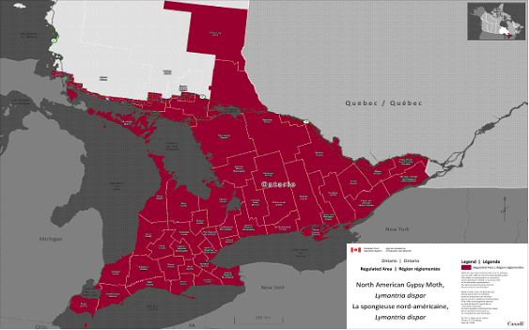

**Palomilla Gitana Norteamericana** (*Lymantria dispar*)- Mapa de las áreas reguladas en Ontario.

|  |  |
| --- | --- |
| Ontario - Lista de áreas infestadas por Palomilla Gitana Norteamericana (*Lymantria dispar*) | |
| **Condados, Municipios Regionales y Distritos** | **Área Regulada por infestaciones parciales en el Condado** |
| Algoma District | All areas south of Highway 17 east of and including the city of Sault Ste. Marie, plus the entire geographic townships of St. Joseph's Island, Denis; Prince; Parke; Korah; Tarentorus; Rankin Location 15D and Garden River 14; MacDonald; Laird; Tarbutt; Tarbutt Additional; Johnson; Plummer; Plummer Additional; Lefroy; Thessalon; Bright Additional; Bright; Thompson; Cobden; Striker; Long; Spragge; Lewis; Shedden; Indian Reserve no. 7. |
| Brant County |  |
| City of Brantford |  |
| Bruce County |  |
| Community of Chatham-Kent |  |
| Dufferin County |  |
| Regional Municipality of Durham |  |
| Elgin County |  |
| Essex County |  |
| Frontenac County |  |
| Grey County |  |
| Haldimand County |  |
| Haliburton County |  |
| Regional Municipality of Halton |  |

|  |  |
| --- | --- |
| City of Hamilton |  |
| Hastings County |  |
| Huron County |  |
| City of Kawartha Lakes |  |
| Lambton County |  |
| Lanark County |  |
| Leeds-Grenville County |  |
| Lennox-Addington County |  |
| Manitoulin District |  |
| Middlesex County |  |
| Muskoka District |  |
| Regional Municipality of Niagara |  |
| Nipissing District |  |
| NorfolkCounty |  |
| Northumberland County |  |
| City of Ottawa |  |
| Oxford County |  |
| District of Parry Sound |  |
| Regional Municipality of Peel |  |

|  |  |
| --- | --- |
| Perth County |  |
| Peterborough County |  |
| Prescott-Russell County |  |
| Prince Edward County |  |
| Renfrew County |  |
| Simcoe County |  |
| Stormont-Dundas-Glengarry County |  |
| Sudbury District | All areas south of Highway 17 and the entire geographic townships of: Victoria; Salter; May; Hallam; Shakespeare; Dunlop; Porter; Baldwin; Nairn; and Hyman. |
| Greater Sudbury Division | All areas south of highway 17 plus the entire geographic townships of Lorne, Louise, Graham, Waters, McKim, Neelon Dryden, Broder and Dill. |
| Temiskaming District |  |
| City of Toronto |  |
| Regional Municipality of Waterloo |  |
| Wellington County |  |
| Regional Municipality of York |  |

**Región de Quebec**

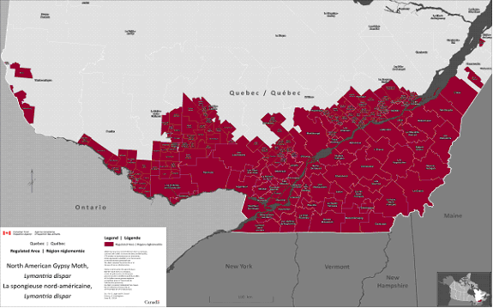

**Palomilla Gitana Norteamericana** (*Lymantria dispar*)– Mapa de áreas reguladas en Quebec.

|  |  |
| --- | --- |
| Quebec - Lista de áreas infestadas por Palomilla Gitana Norteamericana (*Lymantria dispar*) | |
| **Regiones** | **Municipalidades (Indicado para aquellas regiones en las que la región entera no está regulada)** |
| Acton |  |
| Antoine-Labelle | Notre-Dame-du-Laus, Notre-Dame-de-Pontmain, Lac-du-Cerf, Saint-Aimé-du-lac-des-Iles, Kiamika, La Macaza, L'Ascension, Lac-Saguay , Chute-Saint-Philippe, Lac-des-Écorces, Mont-Laurier, Ferme-Neuve, Lac-Saint-Paul, Mont-Saint-Michel, Sainte-Anne-du-Lac, Lac-Ernest, Nomingue, Rivière-Rouge |
| Argenteuil |  |
| Arthabaska |  |
| Beauce-Sartigan |  |
| Beauharnois-Salaberry |  |
| Bécancour |  |
| Bellechasse |  |
| Brome-Missisquoi |  |
| Coaticook |  |
| D'Autray |  |
| Deux Montagnes |  |
| Drummond |  |
| Gatineau |  |
| Joliette |  |
| Kamouraska | Mont-Carmel |
| La Côte de Beaupré | Beaupré, Sainte-Anne-de-Beaupré, Château-Richer, L'Ange-Gardien, Boischatel |
| La Haute-Yamaska |  |
| La Jacques-Cartier | Sainte-Catherine-de-la-Jacques-Cartier, Fossambault-sur-le-Lac, Lac-Saint-Joseph, Shannon, Saint-Gabriel-de-Valcartier, Lac-Delage, Stoneham-et-Tewkesbury, Lac-Beauport, Sainte-Brigitte-de-Laval |

|  |  |
| --- | --- |
| La Nouvelle-Beauce |  |
| La Rivière du Nord |  |
| La Vallée-de-la Gatineau | Denholm, Low, Kazabazua, Lac-Sainte-Marie, Gracefield, Cayamant, Blue Sea, Bouchette, Sainte-Thérèse-de-la-Gatineau, Messines, Déléage, Egan-Sud, Bois-Franc, Aumond, Maniwaki, Grand-Remous, Montcerf-Lytton |
| La Vallée-du-Richelieu |  |
| L'Assomption |  |
| Laval |  |
| Le Granit |  |
| Le Haut Richelieu |  |
| Le Haut-Saint-Laurent |  |
| Le Haut-Saint-François |  |
| Le Val-Saint-François |  |
| L'érable |  |
| Les Appalaches |  |
| Les Chenaux |  |
| Les Collines-de-l'Outaouais |  |
| Les Etchemins |  |
| Les Jardins de Napierville |  |
| Les Laurentides |  |
| Les Maskoutains |  |
| Les Moulins |  |
| Les Pays d'en Haut |  |
| Les Sources |  |
| Lévis |  |
| L'Ile d'Orléans |  |
| L'Islet |  |
| Longueuil |  |
| Lotbinière |  |
| Marguerite-D'Youville |  |
| Maskinongé |  |

|  |  |
| --- | --- |
| Matawinie | Saint-Félix-de-Valois M, Saint-Jean-de-Matha, Sainte-Béatrix, Saint-Alphonse-Rodriguez, Sainte-Marcelline-de-Kildare, Rawdon, Chertsey, Entrelacs, Notre-Dame-de-la-Merci, Saint-Donat, Saint-Côme, Sainte-Émélie-de-l'Énergie, Saint-Damien, Saint-Zénon, Saint-Michel-des-Saints |
| Mékinac | Notre-Dame-de-Montauban, Lac-aux-Sables, Saint-Adelphe, Saint-Sévérin, Saint-Tite V, Hérouxville, Grandes-Piles V, Saint-Roch-de-Mékinac, Sainte-Thècle |
| Memphrémagog |  |
| Mirabel |  |
| Montcalm |  |
| Montmagny |  |
| Montréal |  |
| Nicolet-Yamaska |  |
| Papineau |  |
| Pierre-De-Saurel |  |
| Pontiac | Bristol, Shawville, Clarendon, Portage-du-Fort, Bryson, Campbell's Bay, Litchfield, Thorne, Alleyn-et-Cawood, Fort-Coulonge, Mansfield-et-Pontefract, Waltham, L'Isle-aux-Allumettes, Chichester, Rapides-des-Joachims, L'Île-du-Grand-Calumet, Otter Lake, Sheenboro |
| Portneuf | Neuville, Pont-Rouge, Donnacona, Cap-Santé, Saint-Basile, Portneuf, Deschambault-Grondines, Saint-Gilbert, Saint-Marc-des-Carrières, Saint-Casimir, Saint-Thuribe, Saint-Ubalde, Saint-Alban, Sainte-Christine-d'Auvergne, Saint-Léonard-de-Portneuf, Lac-Sergent, Saint-Raymond, Rivière-à-Pierre |
| Québec |  |
| Rivière-du-loup | Rivière-du-Loup |
| Robert-Cliche |  |
| Roussillon |  |
| Rouville |  |
| Shawinigan |  |
| Sherbrooke |  |
| Témiscamingue | Témiscaming , Béarn, Ville-Marie |
| Thérèse de Blainville |  |
| Trois-Rivières |  |
| Vaudreuil-Soulanges |  |

**Estados Unidos de América**

Los siguientes Estados son áreas completamente infestadas por Palomilla Gitana Norteamericana (*Lymantria dispar*)

• Connecticut

• Delaware

• District of Columbia

• Maryland

• Massachusetts

• Michigan

• New Hampshire

• New Jersey

• New York

• Pennsylvania

• Rhode Island

• Vermont

Partes de los siguientes Estados se encuentran dentro de las áreas infestadas por Palomilla Gitana Norteamericana (*Lymantria dispar*):

Indiana

Condados de:

• Allen

• Elkart

• DeKalb

• LaGrange

• LaPorte

• Noble

• Porter

• Steuben

• St. Joseph

Illinois

Condados de:

• Cook

• Du Page

• Lake

• McHenry

Maine

Condados de:

• Androscoggin

• Cumberland

• Hancock

• Kennebec

• Knox

• Lincoln

• Sagadahoc

• Waldo

• Washington

• York

Regiones sureñas/ Condados de:

• Aroostook

• Franklin

• Oxford

• Penobscot

• Piscataquis

• Somerset

Minnesota

Condados de:

• Cook

• Lake

North Carolina

Todo el Condado de Currituck y la región Este del Condado de Dare (barrier island).

Ohio

Condado de:

• Athens

• Ashland

• Ashtabula

• Belmont

• Carroll

• Columbiana

• Coshocton

• Crawford

• Cuyahoga

• Defiance

• Delaware

• Erie

• Fairfield

• Franklin

• Fulton

• Geauga

• Guernsey

• Harrison

• Henry

• Hocking

• Holmes

• Huron

• Jefferson

• Knox

• Lake

• Licking

• Lorain

• Lucas

• Mahoning

• Marion

• Medina

• Morgan

• Monroe

• Morrow

• Muskingum

• Noble

• Ottawa

• Perry

• Portage

• Richland

• Sandusky

• Seneca

• Stark

• Summit

• Trumbull

• Tuscarawas

• Vinton

• Washington

• Wayne

• Williams

• Wood

Virginia

Condado de:

• Accomack

• Albemarle

• Alleghany

• Amelia

• Amherst

• Appomattox

• Arlington

• Augusta

• Bath

• Bedford

• Bland

• Botetourt

• Brunswick

• Buckingham

• Campbell

• Caroline

• Charles City

• Charlotte

• Chesterfield

• Clarke

• Craig

• Culpeper

• Cumberland

• Dinwiddie

• Essex

• Fairfax

• Fauquier

• Floyd

• Fluvanna

• Franklin

• Frederick

• Giles

• Gloucester

• Goochland

• Greene

• Greensville

• Halifax

• Hanover

• Henrico

• Highland

• Isle of Wight

• James City

• King and Queen

• King George

• King William

• Lancaster

• Loudoun

• Louisa

• Lunenburg

• Madison

• Mathews

• Mecklenburg

• Middlesex

• Montgomery

• Nelson

• New Kent

• Northampton

• Northumberland

• Nottoway

• Orange

• Page

• Pittsylvania

• Powhatan

• Prince Edward

• Prince George

• Prince William

• Pulaski

• Roanoke

• Rappahannock

• Richmond

• Rockbridge

• Rockingham

• Shenandoah

• Southhampton

• Spotsylvania

• Stafford

• Surry

• Sussex

• Tazewell

• Warren

• Westmoreland

• York

Ciudades de:

• Alexandria

• Buena Vista

• Bedford

• Charlottesville

• Chesapeake

• Colonial Heights

• Covington

• Danville

• Emporia

• Fairfax

• Falls Church

• Franklin

• Fredricksburg

• Hampton

• Harrisonburg

• Hopewell

• Lexington

• Lynchburg

• Manassas

• Manassas Park

• Newport News

• Norfolk

• Petersburg

• Poquoson

• Portsmouth

• Radford

• Roanoke

• Richmond

• Salem

• South Boston

• Staunton

• Suffolk

• Virginia Beach

• Waynesboro

• Williamsburg

• Winchester

West Virginia

Condados de:

• Barbour

• Berkeley

• Braxton

• Brooke

• Calhoun

• Doddridge

• Fayette

• Grant

• Gilmer

• Greenbriar

• Hampshire

• Hancock

• Hardy

• Harrison

• Jackson

• Jefferson

• Lewis

• Marion

• Marshall

• McDowell

• Mercer

• Mineral

• Monongalia

• Monroe

• Morgan

• Nicholas

• Ohio

• Pendleton

• Pleasants

• Pocahontas

• Preston

• Raleigh

• Randolph

• Ritchie

• Summers

• Taylor

• Tyler

• Tucker

• Upshur

• Webster

• Wetzel

• Wirt

• Wood

• Wyoming

Wisconsin

Condados de:

• Adams

• Ashland

• Bayfield

• Brown

• Calumet

• Clark

• Columbia

• Dane

• Door

• Dodge

• Florence

• Fond du Lac

• Forest

• Green Lake

• Iowa

• Iron

• Jackson

• Jefferson

• Juneau

• Kenosha

• Kewaunee

• Langlade

• Lincoln

• Manitowoc

• Marathon

• Marinette

• Marquette

• Menominee

• Milwaukee

• Monroe

• Oconto

• Oneida

• Outagamie

• Ozaukee

• Portage

• Price

• Racine

• Rock

• Sauk

• Shawano

• Sheboygan

• Taylor

• Vilas

• Walworth

• Washington

• Waukesha

• Waupaca

• Waushara

• Winnebago

• Woodv